Instagram

1. Logon to instagram.com in your web browser.

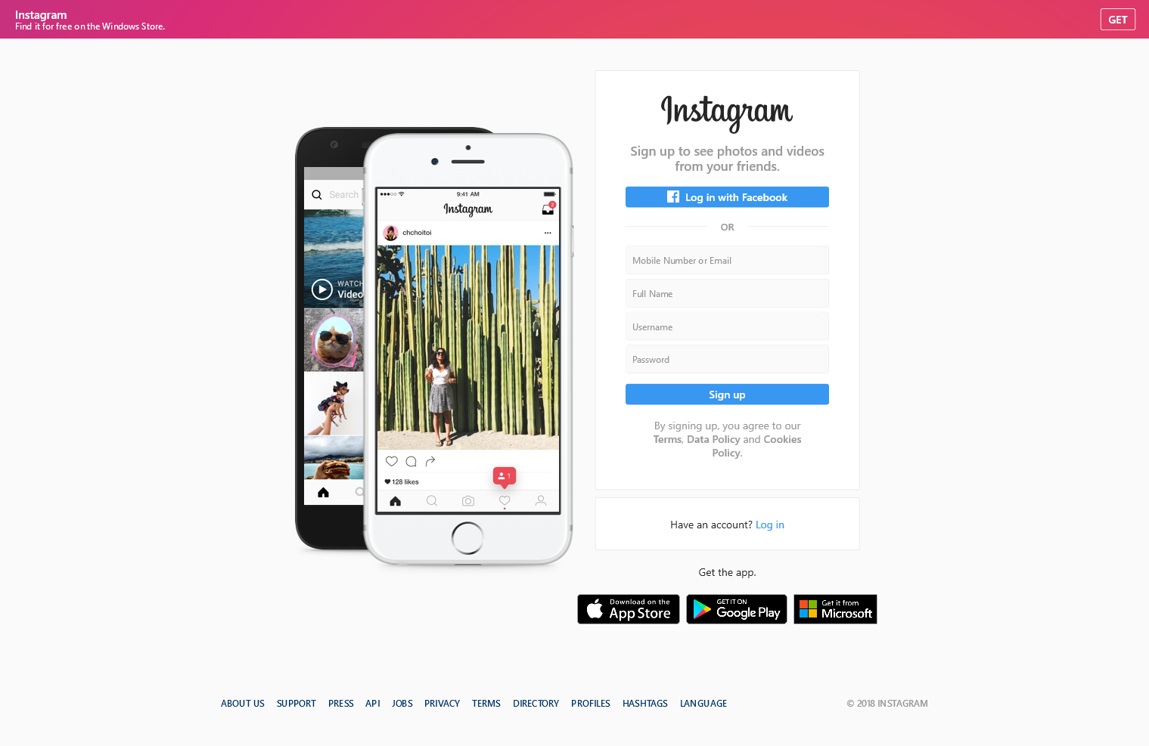

1. Enter your email address, your Full Name, create a username and a password or click Log in with Facebook to sign up with your Facebook account. If you register with Facebook, you'll be prompted to log into your Facebook account if you're currently logged out.
2. Open the email account used to register on Instagram. Open the verification email. It may take a few minutes for the email to get delivered. Click the link in the email to activate your account. To finish creating your account, you need to confirm your email.
3. If you sign up with email, make sure you enter your email address correctly and choose an email address that only you can access. If you log out and forget your password, you'll need to be able to access your email to get back into your Instagram account.
4. Now you'll need to customize the kind of content you want to see in your Instagram feed, such as following the account of Microsoft to stay up to date about its latest technologies.

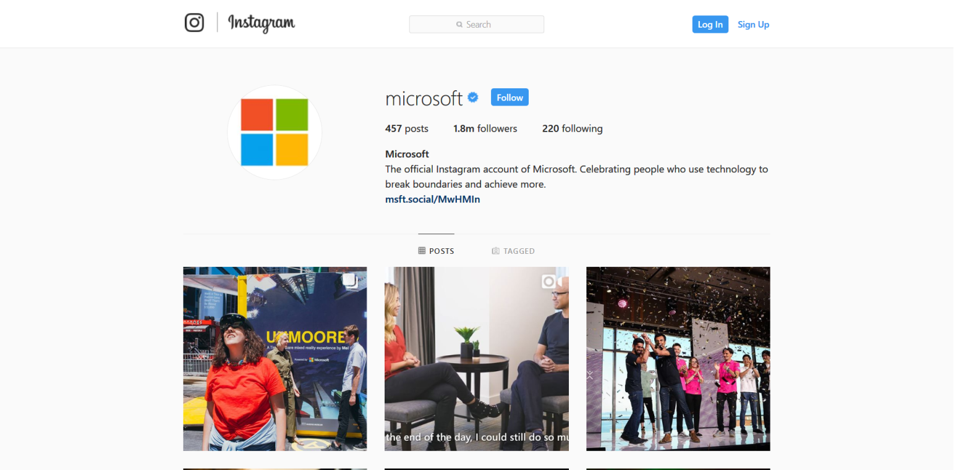

1. **You can now start sharing.** To take a photo, tap the camera icon in the middle of the dock. Take a picture and then apply effects and filters by simply tapping on them. Share to your friends to see!